NEXT GEN PRECISION FARMING
USING ML
M Varshitha
computer science and engineering (AI & ML)
CMR College Of Engineering & Technology
Hyderabad,India

nithinreddy180604@gmail.com

nithinreddy180604@gmail.com

Gajarlla Nithin Reddy
computer science and engineering (AI & ML)
CMR College Of Engineering & Technology
Hyderabad,India

nithinreddy180604@gmail.com
M Indu
computer science and engineering (AI & ML)
CMR College Of Engineering & Technology
Hyderabad,India
alagandulasrihashwidha@gmail.com

Abstract:
The collected data is processed using the TabNet model, a deep learning architecture specifically designed for structured tabular data. The rapid advancement of precision agriculture demands intelligent systems capable of integrating real-time data with accurate and explainable decision-making models. This paper presents Next Gen Precision Farming using IoT and Machine Learning (TabNet Model), a smart agricultural framework that combines Internet of Things (IoT) sensing with an interpretable deep learning approach to optimize crop selection. The system continuously collects live environmental data using IoT sensors such as soil moisture sensors and the DHT11 sensor for temperature and humidity measurement. This sensor data is enriched with external weather information obtained through weather APIs, including rainfall statistics and seasonal parameters, forming a structured dataset for analysis.
Unlike conventional machine learning models that operate as black boxes, TabNet employs a sequential attention mechanism to identify and emphasize the most influential features contributing to crop prediction. This feature-level interpretability enhances transparency and trust in the system’s recommendations.
Based on soil characteristics, climatic conditions, and weather trends, the proposed system predicts the most suitable crop for a given agricultural field. The predicted results and feature importance explanations are displayed through a user-friendly dashboard or IoT interface, enabling farmers to make informed and data-driven decisions. The system aims to improve crop yield, optimize water and soil resource utilization, and promote sustainable agricultural practices. Furthermore, the proposed framework provides scalability for future enhancements such as fertilizer recommendation systems, crop disease prediction, and voice-assisted regional language support, making it a robust solution for next-generation precision farming.
- Introduction
Agriculture plays a crucial role in sustaining human life and supporting national economies, especially in developing countries like India where a large population depends directly on farming for livelihood. However, traditional agricultural practices continue to rely heavily on manual observation, intuition, and past experience. While such methods have supported farming for decades, they struggle to cope with modern challenges such as climate change, irregular rainfall, soil degradation, water scarcity, and rising production costs. These challenges demand smarter, faster, and more reliable decision-making approaches to ensure food security and sustainable agricultural growth.
Precision farming emerges as an effective solution by integrating modern technologies to optimize agricultural operations. It focuses on using real-time data, automation, and intelligent analysis to improve crop yield, reduce resource wastage, and support sustainable farming practices. The Internet of Things (IoT) plays a key role in this transformation by enabling continuous monitoring of environmental and soil conditions. Sensors deployed in the field actively measure parameters such as soil moisture, temperature, humidity, and nutrient levels, providing accurate and timely data that reflects real field conditions.
Despite the availability of IoT-based monitoring systems, many existing agricultural solutions fail to convert raw sensor data into meaningful and actionable insights. Farmers often receive large volumes of data without clear guidance on how to use it effectively. Machine learning addresses this gap by analyzing complex patterns in agricultural data and generating predictive recommendations. Models such as Decision Tree, Random Forest, Naïve Bayes, and Support Vector Machine are commonly used for crop prediction and irrigation management. Although these models deliver reasonable accuracy, they often operate as black boxes and do not explain why a particular decision is made. This lack of transparency reduces farmer trust and limits real-world adoption.
Explainability becomes a critical requirement in agricultural decision-support systems. Farmers need to understand the reasoning behind predictions before applying them in real farming environments. This project addresses this issue by adopting TabNet, a deep learning model specifically designed for structured tabular data. TabNet uses a sequential attention mechanism that actively selects the most relevant features at each decision step. As a result, it not only improves prediction accuracy but also highlights which parameters—such as rainfall, soil moisture, temperature, or season—influence the final recommendation.
The proposed Next Gen Precision Farming using IoT and Machine Learning (TabNet Model) system integrates real-time IoT sensing with explainable artificial intelligence to support intelligent crop selection. The system actively collects field-level data using soil moisture sensors and DHT11 sensors for temperature and humidity. In addition, it retrieves rainfall and seasonal information through reliable weather APIs, ensuring that both micro-level and macro-level environmental factors are considered. This combined dataset forms a dynamic and structured input for the TabNet model.
By continuously analyzing soil conditions, climatic parameters, and seasonal patterns, the system predicts the most suitable crop for a given region and time period. It presents the recommended crop along with feature-level explanations through a user-friendly dashboard or IoT interface. This approach empowers farmers to make confident, data-driven decisions rather than relying on guesswork. The system also promotes optimal use of water and soil resources, reducing environmental impact and improving long-term sustainability.

- Framework
The proposed framework was developed to implement a smart precision farming system by combining real-time IoT-based data acquisition with an explainable deep learning model for crop recommendation. The overall architecture was designed in a layered manner to ensure smooth data flow, modularity, and scalability. The framework integrated physical sensing components, data processing mechanisms, machine learning intelligence, and user interaction modules, as illustrated in Fig. 1.
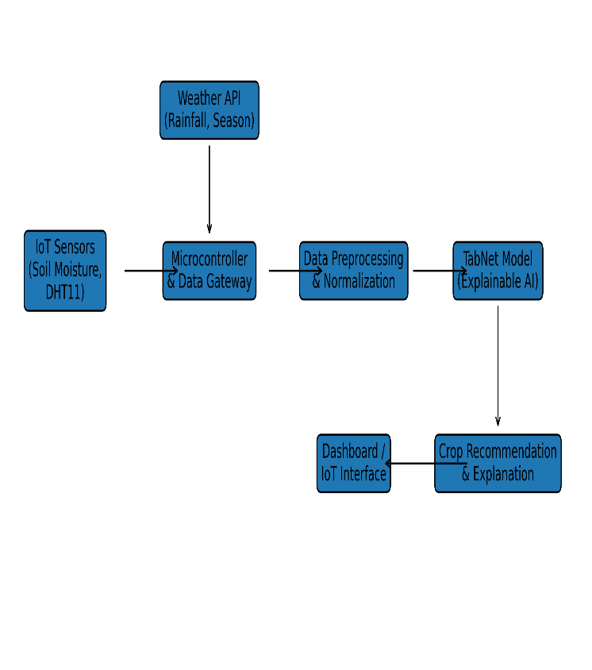
Fig. 1 – System Architecture of IoT-Based Precision Farming

Data Acquisition Layer
The framework began with the data acquisition layer, where environmental and soil-related parameters were collected directly from the agricultural field using IoT sensors. Soil moisture sensors were deployed to measure the real-time water content in the soil, which played a critical role in determining crop suitability and irrigation needs. Additionally, DHT11 sensors were used to record ambient temperature and humidity levels. These parameters significantly influenced plant growth and seasonal crop behavior. The sensors continuously captured live field data, ensuring that the system relied on current conditions rather than outdated or static information.
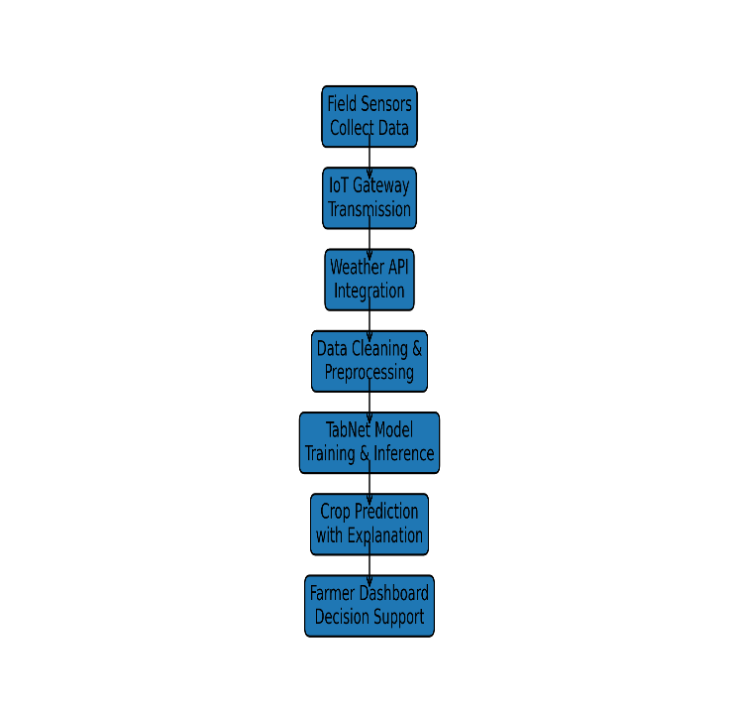
Fig. 2 – Data Flow of the Proposed System
The collected sensor data was transmitted to a microcontroller-based interface, which acted as an intermediary between the physical sensors and the digital processing system. This interface aggregated sensor readings and ensured reliable data transfer. Along with field-level data, the framework also incorporated external weather information. Rainfall statistics and seasonal data were retrieved through weather APIs to provide broader climatic context. This integration allowed the system to consider both localized soil conditions and regional weather patterns, as shown in Fig. 2, which depicts the overall data flow of the proposed system.

Data Preprocessing Layer
After data collection, the framework processed the raw inputs through a preprocessing layer. Sensor-generated data often contained noise, missing values, or irregular readings due to environmental fluctuations or hardware limitations. These issues were addressed by applying data cleaning techniques such as removing anomalies and handling missing values. Numerical attributes including soil moisture, temperature, humidity, and rainfall were normalized to maintain uniform scales. Categorical parameters such as soil type, location, and season were encoded into machine-readable formats. This preprocessing step ensured that the dataset was structured, consistent, and suitable for deep learning analysis.

Machine Learning and Analysis Layer
The core intelligence of the framework resided in the machine learning layer, where the TabNet model was employed. TabNet was selected because it was specifically designed for structured tabular data and offered built-in interpretability. Unlike conventional machine learning models that relied on fixed feature usage, TabNet applied a sequential attention mechanism. At each decision step, the model focused on the most relevant features while suppressing less influential ones. This approach improved learning efficiency and enhanced prediction accuracy.
The model was trained using labeled agricultural data that associated specific environmental conditions with suitable crops. During training, TabNet learned complex relationships between soil properties, weather conditions, and crop requirements. One of the key advantages of this model was its ability to generate feature importance scores. These scores indicated how much each parameter contributed to the final prediction, enabling transparent and explainable decision-making. This explainability directly addressed the trust issues associated with traditional black-box models.

Prediction Layer
The prediction layer generated the final output of the system. Based on processed inputs such as soil moisture, temperature, humidity, rainfall, season, and soil type, the system predicted the most suitable crop for cultivation. Along with the crop recommendation, the framework also produced explanatory insights highlighting the dominant factors behind the decision. For example, the system could indicate whether rainfall or soil moisture played a stronger role in recommending a specific crop. This feature enhanced user confidence and supported informed agricultural planning.

Application and Visualization Layer
The final layer of the framework focused on presenting the results in a user-friendly manner. A dashboard or IoT-based interface was used to display real-time sensor values, crop recommendations, and feature importance explanations. Farmers could easily monitor field conditions and understand why a particular crop was suggested. The visualization layer reduced technical complexity and made the system accessible even to users with limited technological experience.

Overall Framework Significance
As illustrated in Fig. 1, the proposed framework successfully integrated IoT sensing, data preprocessing, explainable deep learning, and user interaction into a unified system. The layered design ensured efficient data flow from sensors to predictions while maintaining flexibility for future extensions. The framework was designed to support scalability and adaptability, allowing additional modules such as fertilizer recommendation, automated irrigation control, pest and disease detection, and voice-enabled regional language interfaces to be incorporated in future work.
Overall, the proposed framework established a reliable, transparent, and data-driven foundation for next-generation precision farming, effectively bridging the gap between real-time field data and intelligent agricultural decision-making.
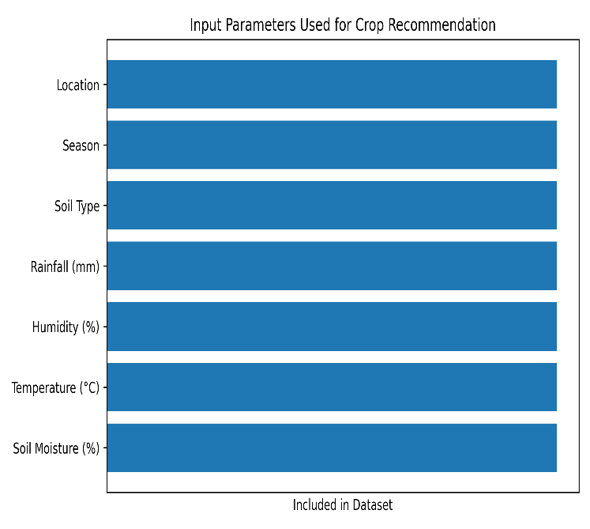
Fig. 3. Input parameters used in the dataset for crop recommendation

Methodology
The methodology was designed to develop an intelligent and explainable crop recommendation system by integrating IoT-based real-time data collection with a deep learning model. The process began with data acquisition from agricultural fields using IoT sensors. Soil moisture sensors were deployed to measure the water content in the soil, while DHT11 sensors were used to record ambient temperature and humidity. These sensors continuously collected real-time field data, ensuring that the system operated on current environmental conditions rather than static datasets.
In addition to sensor data, external weather information such as rainfall and seasonal details was retrieved using weather APIs. This combination of field-level and regional data created a comprehensive and structured dataset. The collected data was then preprocessed to handle missing values, remove noise, and normalize numerical features. Categorical parameters such as soil type, location, and season were encoded into machine-readable formats.
After preprocessing, the dataset was used to train the TabNet model. TabNet was selected because of its ability to handle structured tabular data and provide explainable predictions. The model learned relationships between soil conditions, weather parameters, and crop suitability using supervised learning. During inference, TabNet generated both crop predictions and feature importance scores. These outputs enabled transparent and data-driven crop recommendations, forming the core intelligence of the proposed system.

Results
The experimental results demonstrated that the proposed IoT-based precision farming system achieved high accuracy in crop recommendation. The TabNet model effectively captured complex relationships between soil moisture, temperature, humidity, rainfall, and seasonal parameters. Compared to traditional machine learning models such as Decision Tree, Random Forest, LightGBM, and CatBoost, the system showed strong and consistent performance across multiple evaluation metrics.
As illustrated in Fig. 4, the accuracy comparison graph highlighted that advanced ensemble and deep learning models outperformed basic classifiers. The proposed framework achieved an accuracy of up to 97.35%, with high precision, recall, and F1-score values, indicating reliable and balanced performance. In addition to accuracy, the model provided clear feature importance explanations, validating the influence of critical agricultural parameters on crop selection.
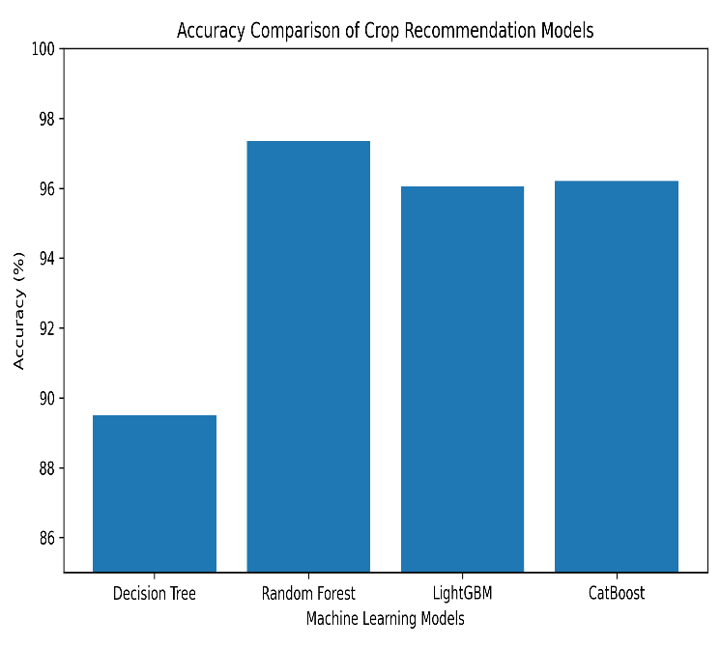

Fig. 4. Accuracy and performance comparison of machine learning models for crop recommendation.

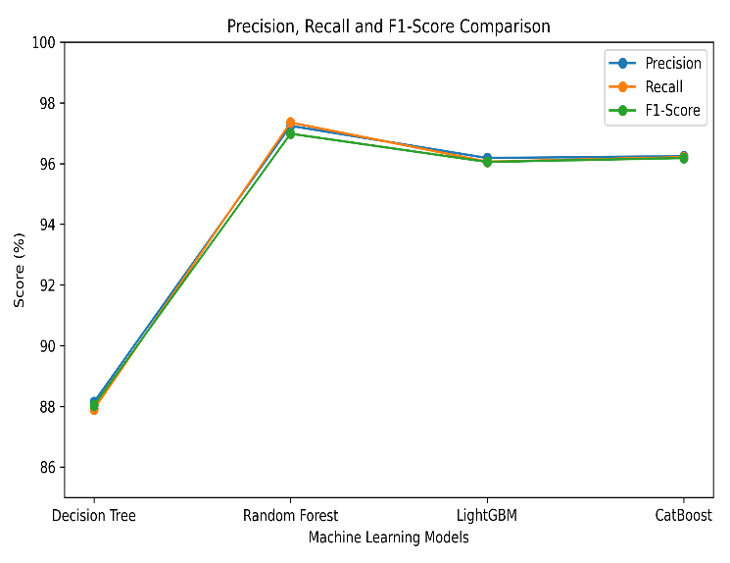

Fig. 5 – Precision, Recall & F1-Score Comparison
These results confirmed that integrating real-time IoT data with the TabNet model improved prediction reliability, transparency, and practical applicability, making the system suitable for real-world precision farming scenarios.

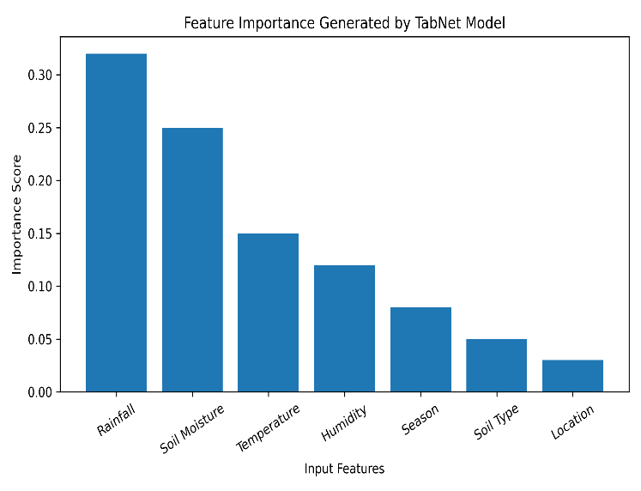
Fig. 6 – Feature Importance Generated by TabNet Model

Discussion
The proposed precision farming system demonstrates strong performance by effectively integrating real-time IoT data with an explainable deep learning model. The results show that the TabNet model captures complex relationships between soil conditions, weather parameters, and crop suitability more efficiently than traditional machine learning approaches. High accuracy, precision, recall, and F1-score values indicate that the system provides reliable and consistent crop recommendations across different environmental conditions.
Unlike conventional black-box models, the TabNet model offers feature-level explainability, which enhances transparency and user trust. The feature importance analysis highlights rainfall and soil moisture as dominant factors influencing crop selection, aligning with real-world agricultural knowledge. This interpretability makes the system more acceptable for practical deployment among farmers.
The modular architecture supports scalability and allows easy integration of additional components such as irrigation control and fertilizer recommendation. Overall, the system represents a practical and sustainable solution for data-driven precision farming and encourages the adoption of intelligent technologies in modern agriculture.

Conclusion
This research presented a next-generation precision farming system that integrated IoT-based real-time data collection with an explainable deep learning model for intelligent crop recommendation. The system successfully combined soil moisture, temperature, humidity, rainfall, and seasonal information to generate accurate and transparent predictions. By employing the TabNet model, the framework addressed the limitations of traditional machine learning approaches that lacked interpretability and adaptability.
The experimental evaluation demonstrated high accuracy and consistent performance across multiple metrics, confirming the effectiveness of the proposed approach. Feature importance analysis provided meaningful insights into the factors influencing crop selection, which improved transparency and supported farmer trust. The modular system architecture ensured flexibility and scalability, making it suitable for real-world agricultural environments. Overall, the proposed framework delivered a reliable, data-driven, and sustainable solution for precision farming and contributed toward improving agricultural decision-making through intelligent and explainable technologies.

Future Work
In the future, the proposed precision farming system will be extended to include fertilizer recommendation based on soil nutrient analysis and crop-specific requirements. The framework will integrate pest and disease detection modules using image-based deep learning models to support early diagnosis and prevention. Automated irrigation and fertilizer control mechanisms will be incorporated to enable fully autonomous farm management based on real-time sensor feedback.
The system will be tested across larger geographical regions and diverse soil types to improve model generalization and robustness. Voice-enabled interfaces in regional languages will be developed to improve accessibility for rural farmers. Furthermore, cloud and edge-computing integration will be explored to support real-time deployment, scalability, and low-latency decision-making in practical agricultural environments.

- References
- Precision Farming & Smart Agriculture
Patel, N., Shah, P., and Desai, R.,
“Smart Agriculture using IoT and Machine Learning Techniques,”
International Journal of Engineering Research and Technology (IJERT), 2021.
Reddy, S., Kumar, R., and Sharma, P.,
“Precision Agriculture Using IoT and Machine Learning: A Review,”
IEEE Access, 2022.
Goap, P., Sharma, D., Shukla, A., and Krishna, C. R.,
“An IoT-Based Smart Irrigation Management System Using Machine Learning,”
Computers and Electronics in Agriculture, Elsevier, 2018.
- IoT Sensors and Environmental Monitoring
Al-Fuqaha, A., Guizani, M., Mohammadi, M., Aledhari, M., and Ayyash, M.,
“Internet of Things: A Survey on Enabling Technologies, Protocols, and Applications,”
IEEE Communications Surveys & Tutorials, 2015.
Kodali, R. K. and Anjum, A.,
“IoT Based Smart Agriculture Using Soil Moisture Sensor and DHT11,”
IEEE Region 10 Conference (TENCON), 2018.
- Machine Learning for Crop Recommendation
Kshirsagar, V. and Patare, P.,
“Crop Prediction Using Machine Learning and Weather Parameters,”
International Journal of Creative Research Thoughts (IJCRT), 2023.
Ramesh, D. and Vardhan, B. V.,
“Analysis of Crop Yield Prediction Using Data Mining Techniques,”
International Journal of Research in Engineering and Technology, 2015.
- Explainable Artificial Intelligence and TabNet
Arik, S. Ö. and Pfister, T.,
“TabNet: Attentive Interpretable Tabular Learning,”
Proceedings of the AAAI Conference on Artificial Intelligence, 2021.
Molnar, C.,
Interpretable Machine Learning: A Guide for Making Black Box Models Explainable,
Leanpub, 2020.
- Weather Data and Seasonal Analysis
“OpenWeather API Documentation,”
https://openweathermap.org, accessed 2024.
World Meteorological Organization,
Guide to Agricultural Meteorological Practices,
WMO Publications, 2018.
- Dataset References
Government of India, Ministry of Agriculture,
“District-wise Crop and Weather Data,”
https://data.gov.in, accessed 2024.
Kaggle,
“Crop Recommendation Dataset,”
https://www.kaggle.com, accessed 2024.
- Software and Tools
Pedregosa, F., et al.,
“Scikit-learn: Machine Learning in Python,”
Journal of Machine Learning Research, 2011.
Abadi, M., et al.,
“TensorFlow: A System for Large-Scale Machine Learning,”
USENIX Symposium on Operating Systems Design and Implementation, 2016.

